AUSPICA · BREAK-IN-SERIES REGISTER
User Manual
What this tool is, the problem it solves, and how to use it, with a worked example from first question to answer
The control plane for the AI workforce.

VERSION 1.2
FOR RELEASE 1.3.11
AUGUST 2026
PREPARED BY AUSPICA LLC
No prior knowledge assumed.

CONTENTS
In Word, right-click the table below and choose Update Field to populate it with current page numbers.

§ 01 · THE PROBLEM

What This Is
One question, asked constantly and answered badly: how far back can I trust this data?
This is a tool for answering that question. It is a single file that opens in a web browser. Nothing installs, nothing uploads, and it works with no internet connection. It ships with 202 real, documented examples spanning 1752 to 2024, so you can see how it works before you put any of your own information into it.

The problem, in plain terms
Suppose you are looking at a chart of something measured every year for thirty years. The line goes up. You conclude the thing being measured went up.
That conclusion is only safe if the thing was measured the same way for all thirty years. Often it was not. Somebody changed the definition, replaced the survey, started counting a group that used to be left out, or stopped keeping records past a certain age. The chart still looks like one smooth line, because the column header never changed. It is really several different measurements joined end to end, and nobody marked the joins.
In 1998 the United States lowered the threshold for being classified as overweight. About twenty-nine million people became overweight overnight. Nobody gained weight. Chart obesity across 1998 without knowing that and you are partly charting a committee decision.
These joins are not secret. They sit in methodology notes, change tickets, regulatory filings, and the memories of people who have since left. They are simply not recorded anywhere that connects them to the work depending on them. That is the gap this tool closes.

What it gives you
- A dated list of every known point where a series stopped being comparable with itself.
- For each one: what changed, why, and what it does to the numbers.
- For each report and model: the span of time its data supports, and the specific change that decides the boundary.
- A record you can hand an auditor that explains why you excluded a period or applied a correction.

Who it is for
- Anyone who has to say how far back a number can be trusted, and be right.
- People deciding where a model’s training data should start.
- Analysts comparing this year with a year far enough back that something may have changed underneath.
- Anyone assembling a long history from more than one source.
§ 02 · THE MODEL

The Three Ideas You Need
Understand these three and you can use the tool. There is nothing else to learn.

An event is something that happened
An event is a change somebody made. A definition was rewritten. A survey was replaced. A law changed what could be collected. The event records what happened, when, why, and who did it. That is all it does. On its own it tells you nothing about whether your data is usable.

An impact is what that change did to one particular thing
One event can touch several sets of data, and it does not touch them all the same way. A change to a health classification might wreck the cause-of-death figures and leave hospital admissions untouched.
So each event gets one impact record for each set of data it actually affected. The impact states three things: how bad it is, which side of the date is spoiled, and whether a fix exists. This separation is the point of the tool. It stops a narrow change being blamed for problems it never caused.
The event explains history. The impact decides whether your data is usable. Keeping them apart is why the answers hold up.

A clean window is the answer
For each report or model, the tool works out the stretch of time where none of the known problems apply. That stretch is the clean window. It is calculated, not typed in: change one impact and every window depending on it moves.
There are two versions. The raw window is what the originally published data supports if you do nothing. The adjusted window is what you get once you apply the official corrections that exist. The adjusted window is usually longer, and quoting it commits you to actually applying the correction and saying so.
§ 03 · ORIENTATION

Opening It and Finding Your Way Around
There is no installation. Save the file, open it, and everything runs on your own machine.

Opening it
- Save the file, for example Break-in-Series-Register-v1.3.11.html, somewhere on your own computer.
- Double-click it, or right-click and choose Open with, then your browser. Chrome, Edge, Firefox and Safari all work.
- That is the whole installation.
The strip along the top tells you what you are running and what leaves your machine. Computation is local, nothing is stored between sessions, and the only network requests are for web fonts. If you want to keep changes, export them before closing the tab.
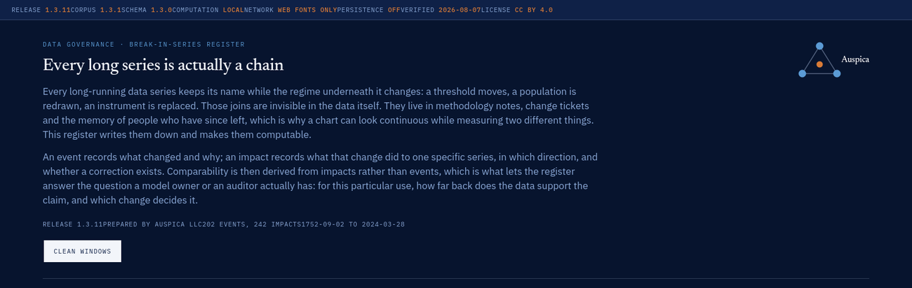
FIGURE 1 The top of the page. The status strip carries the release, corpus and schema versions and the privacy position. The Clean Windows button opens the results appendix.

The six panels
PANEL | WHAT IT IS FOR
01 The breaks | The visual timeline. Every known change plotted by date and subject area.
02 Reconciliation | How well change has been documented over the years.
03 The register | The searchable list of every change, with the detail behind each one.
04 Comparability | A colour grid: for each kind of data, which decades still compare with today.
05 Taxonomy | The dictionary. Every term the tool uses, defined.
06 Your data | Where you load your own information in place of the examples.
Appendix A | Clean windows: the answers. Opened with the button at the top.

The answers sit in an appendix rather than at the top on purpose. They are the part you will use most once you know the tool, and the part that means least before you do.
§ 04 · PANEL 01

The Breaks
Two and a half centuries of documented change, plotted so you can see what lines up with what.
Each dot is one change. The rows are subject areas, so a dot in the Health row is a change that happened to health data.
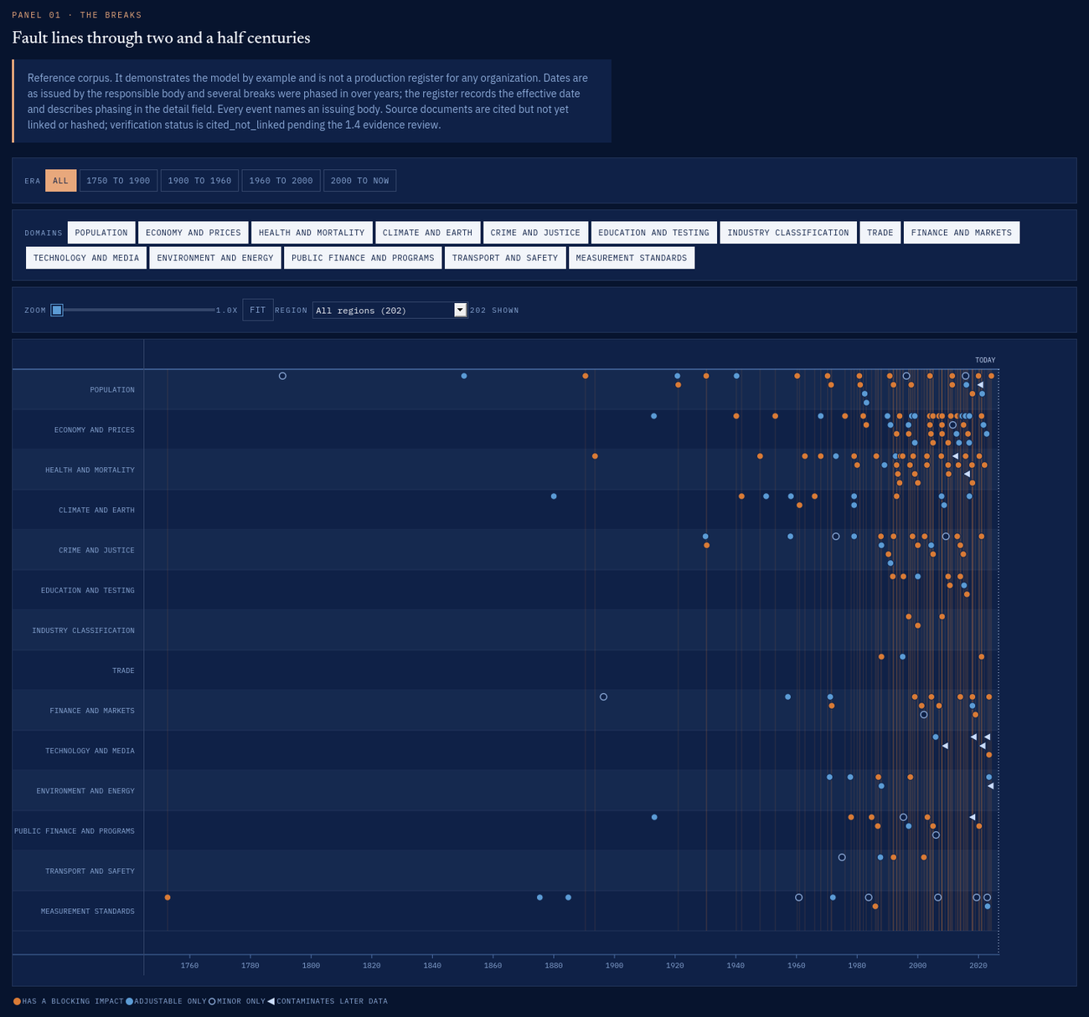
FIGURE 2 Panel 01 at default zoom, showing all 202 changes from 1752 to today. The pale vertical lines are the serious breaks, drawn through every row. The dots thicken sharply after 1950; that is documentation improving, not the world getting worse.

Reading the dots
WHAT YOU SEE | WHAT IT MEANS
Warm filled circle | This change broke something. Data either side cannot simply be compared.
Steel filled circle | This change can be worked around, if a correction exists.
Hollow circle | Worth knowing about, but it stops nothing.
Left-pointing triangle | Unusual and important: this change spoils what came after it, not what came before.
Pale vertical line | A serious break, drawn through all rows so you can see what else it lines up with.
Dotted line marked TODAY | The present, for reference.

The controls
- Era buttons jump to a period and reset the zoom.
- Domain buttons switch subject areas on and off.
- The Zoom slider spreads the timeline out. Drag it right and the drawing scrolls; the row labels stay put.
- Region picks a single country, or the international standards bodies.
- Fit returns you to the whole span.
The recent decades are crowded at the default setting. That is what the zoom is for.
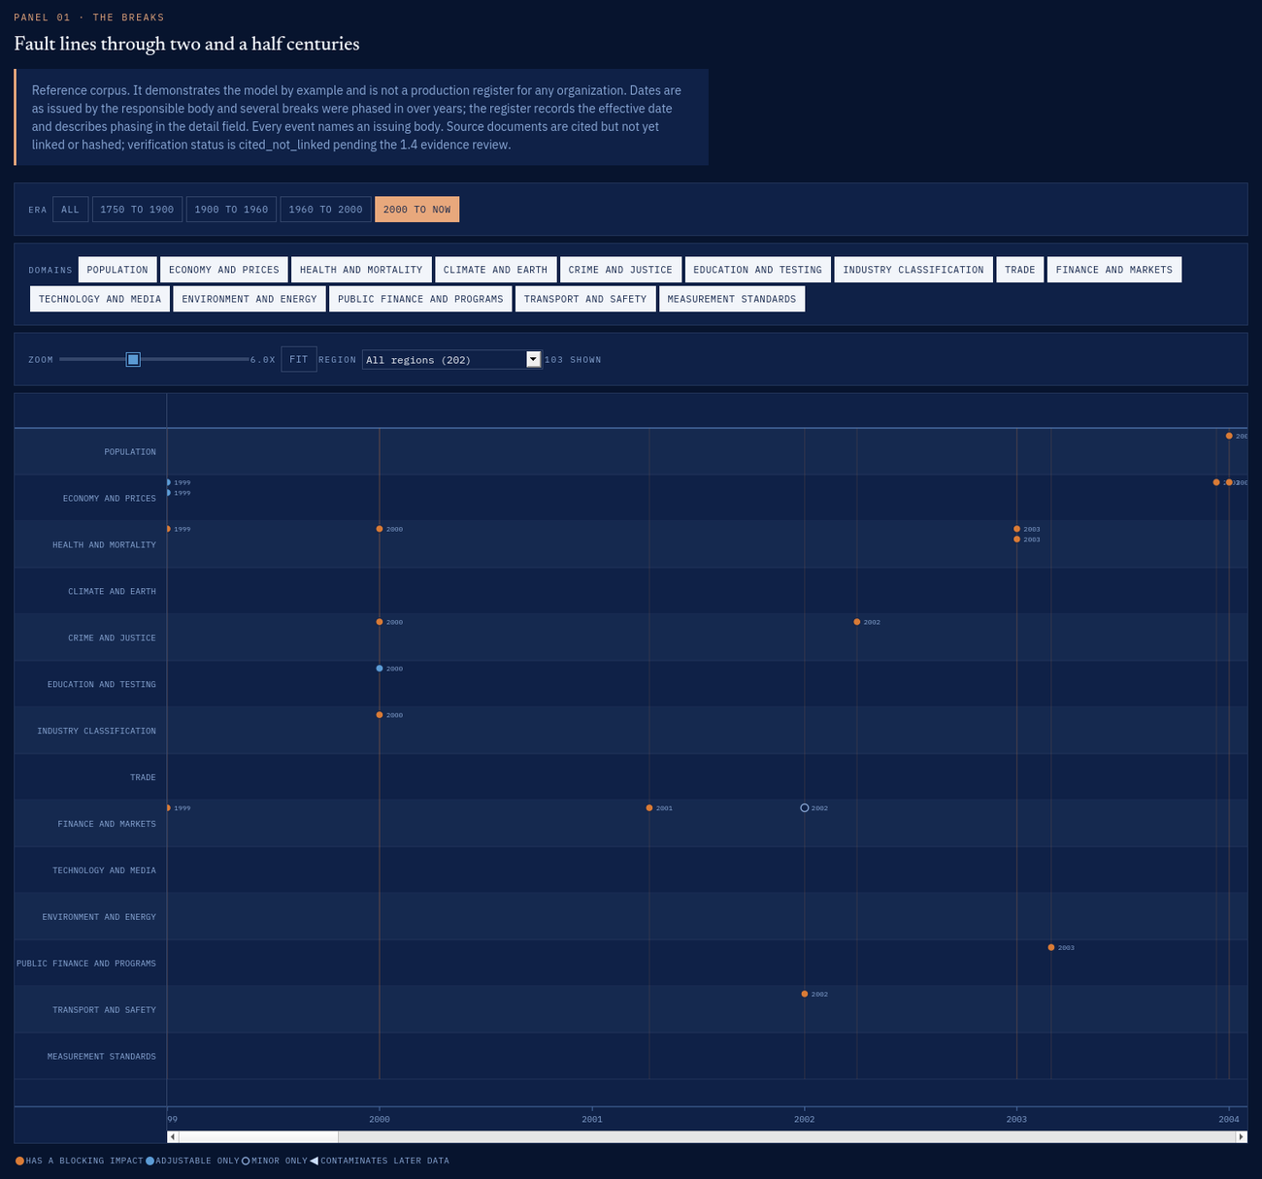
FIGURE 3 The same timeline filtered to 2000 onwards and zoomed to six times. At this magnification the year appears beside each dot, which is enough to separate changes that happened within a few months of each other.

Clicking a dot
Click any dot and the panel on the right fills with the record: what changed, why, what it did, which of your uses inherit the problem, and where the claim comes from. Section 06 walks through one in detail.
§ 05 · PANELS 02 TO 05

The Other Panels
Three views on the same records, each answering a different kind of question.

Panel 02: Reconciliation
Three numbers. Declared means the organization responsible announced the change. Detected means the change is visible in the numbers themselves.
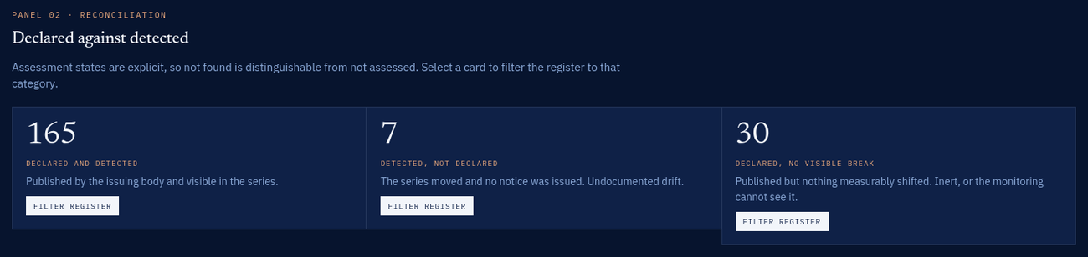
FIGURE 4 Panel 02. Each card filters the register to its category.
- Declared and detected: announced, and it shows up in the data. This is what good looks like.
- Detected, not declared: the numbers moved and nobody said anything. These are the ones that catch people out.
- Declared, no visible break: something was announced but nothing moved. Either it made no difference, or nobody is watching the right measure.

Panel 03: The register
The full list. Type in the filter box to narrow it: the search covers titles, identifiers, data sets, remediation notes and sources, not only the visible text. Click a column heading to sort. Click a title to open the record.
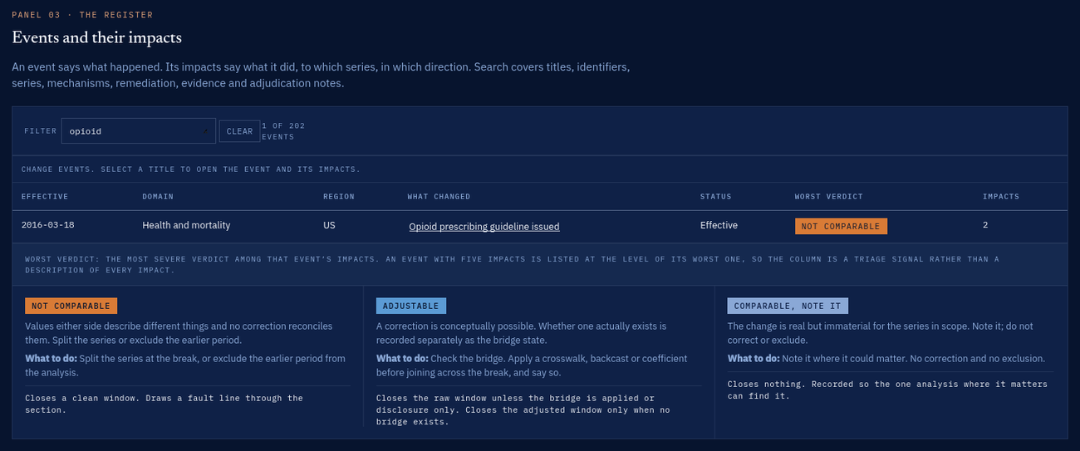
FIGURE 5 Panel 03 filtered to one search term, with the verdict key beneath the table explaining each severity level and what it does to your answer.

Panel 04: Comparability
A grid. Each row is a kind of data, each column a decade, and each square answers one question: take this data from this decade and put it next to today’s, what happens? Read along a row to see when that kind of data settled down.
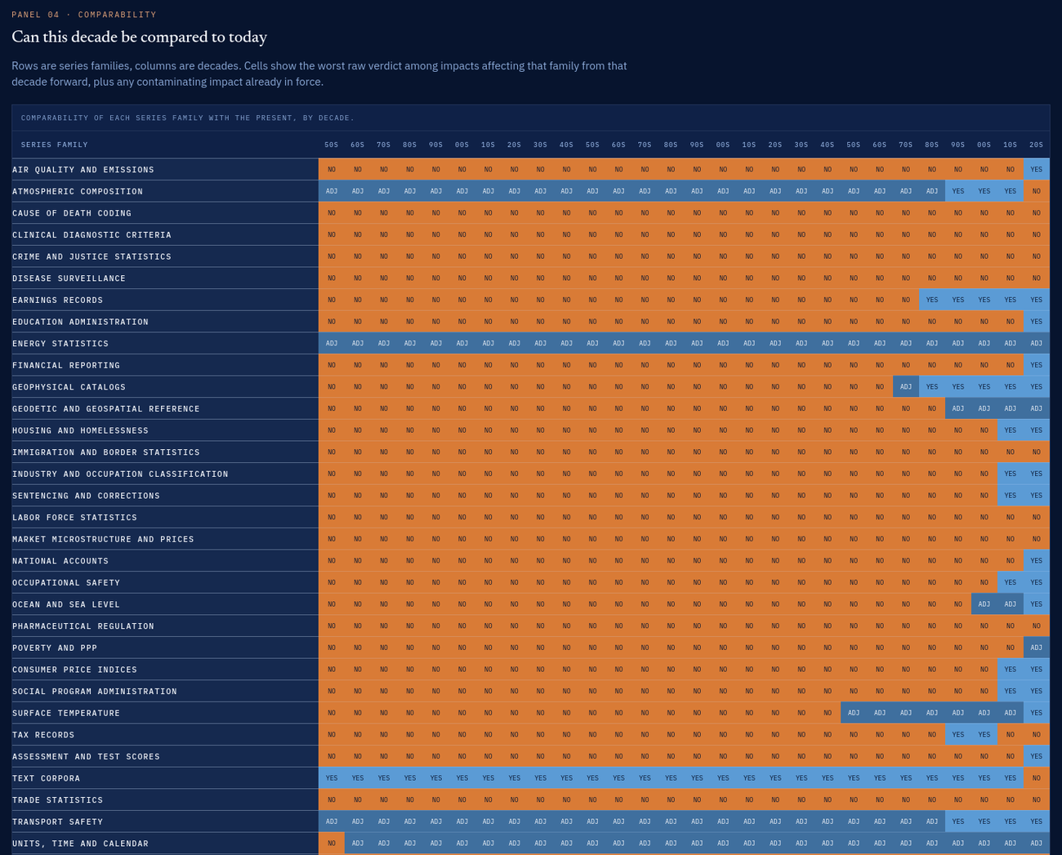
FIGURE 6 Panel 04. Warm squares mark where joining old data to new produces a wrong number.

Panel 05: Taxonomy
The dictionary. Every term the tool uses, grouped by what it describes, each with a definition. The same definitions appear on hover wherever a term is used elsewhere, so you rarely come here twice.
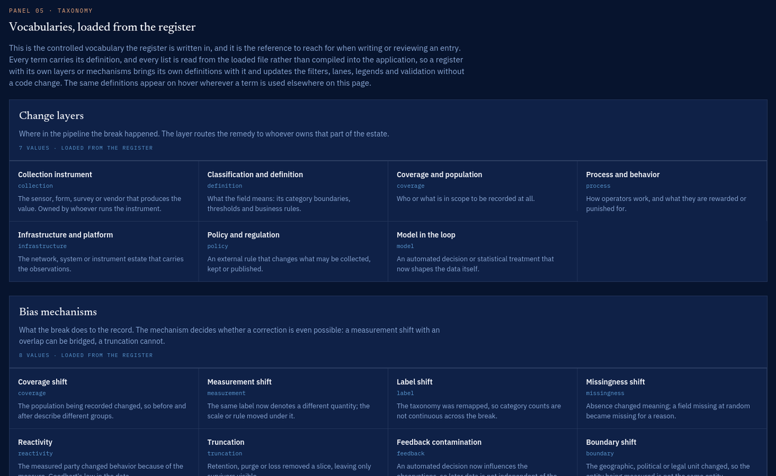
FIGURE 7 Panel 05. Definitions are loaded from the data file rather than built into the program, so a register that brings its own terms brings its own definitions with it.
§ 06 · WORKED EXAMPLE

From Question to Answer
One real question, followed to a defensible answer. Every screen is the tool running on the data it ships with.
The question. Our team watches for safety problems in medicines by looking at reported side effects. Somebody wants a chart going back to 2005. Can we do that?

Step one: open the answers
Click Clean Windows at the top of the page. The appendix opens with one row for each kind of work the register knows about.
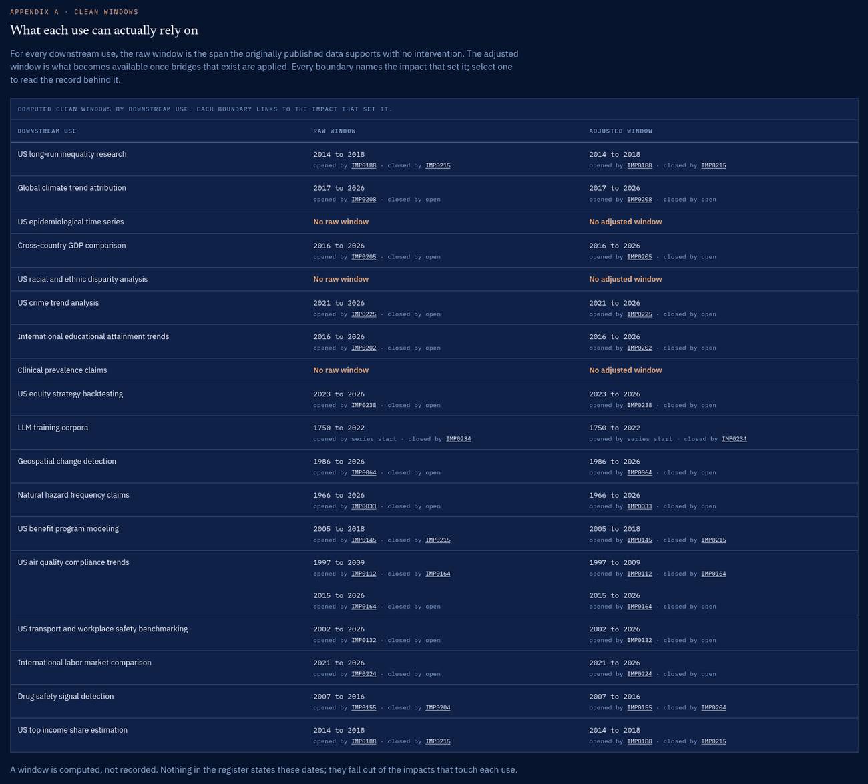
FIGURE 8 Appendix A. Each window is calculated from the changes that touch the data the use relies on. The two identifiers under each window name the change that opened it and the change that closed it.

Step two: read your row
Find Drug safety signal detection. Its raw window reads 2007 to 2016. The answer is no, and it is no in two separate ways: 2005 is too early, and the window has also closed at the recent end.
That second part is the surprising one, and it is what a register catches and a spreadsheet does not. Recent data is not missing. Something happened in 2016 which means recent numbers no longer measure the same thing.

Step three: ask why
Under the window are two identifiers. The first, IMP0155, is what opened it. Click it.
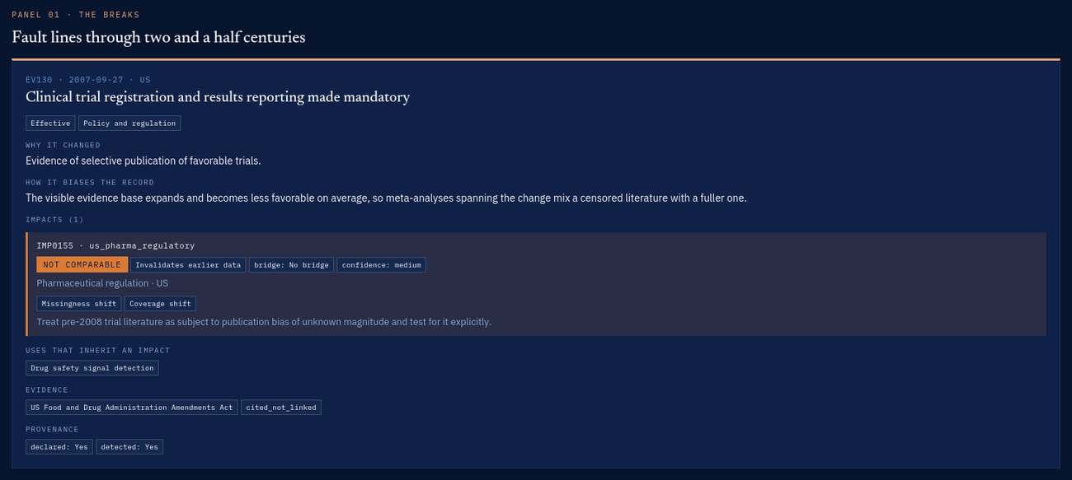
FIGURE 9 The record behind the boundary, with the impact that set it highlighted. In 2007 clinical trial registration became mandatory in the United States.
In plain terms: before 2008 a company could run a trial and not publish it if the result was unflattering. From 2008 it had to be registered. So the older evidence looks better than reality, by an amount nobody can measure. That is why the window will not open earlier, and it is a better reason than the data being old.
Clicking the second identifier, IMP0204, explains the closing boundary. A 2016 prescribing guideline changed prescribing behaviour sharply, so figures after that date reflect the policy as much as the medicines.

Step four: answer the question
You can now answer with a reason attached, which is the point of the exercise:
We can chart this from 2007 to 2016. We cannot start in 2005, because trial registration only became mandatory in 2007 and the earlier evidence is a filtered subset by an unknown amount. We should not run past 2016 on the same axis, because the 2016 prescribing guideline changed the underlying behaviour. If we need the recent period, it goes on a separate chart with that stated.
Compare that with the answer most teams can give today, which is either that the data exists or that somebody should ask a colleague who was there at the time.

What happened underneath
You never touched the calculation. The window came from two impact records; the impacts came from two events; the events name their sources. If somebody disputes the answer, you show them the chain rather than defending a judgement call.
§ 07 · LABELS

Reading Verdicts and Bridges
Two labels on every impact, answering different questions. Confusing them is the common mistake.

Verdict: how bad is it
VERDICT | IN PLAIN TERMS
Not comparable | The two sides measure different things and no arithmetic fixes it. Split the chart or drop the earlier part.
Adjustable | It could be fixed. Whether it actually can be depends on the bridge. Do not read this as fine.
Comparable, note it | Real, but it does not change what you should do. Footnote it if it could matter to someone.

Bridge: does a fix exist, and has anyone applied it
BRIDGE | IN PLAIN TERMS
No bridge | Nobody has produced a way to convert old to new. Adjustable in theory, blocked in practice.
Disclosure only | No sums needed. Say what changed and carry on.
Bridge available, not applied | A conversion exists and somebody published it. You have to apply it, and say that you did.
Applied to current vintage | The organization responsible already restated its own history. Nothing for you to do.

This is why there are two windows rather than one. The raw window assumes you do nothing. The adjusted window assumes you apply every correction that exists. Quote the adjusted window and you have taken on the work.

Direction: which side is spoiled
Most changes spoil the past: a new way of measuring started, so the old numbers are the odd ones out. A smaller group spoils the present, and these are easy to miss. When an automated system starts making decisions, a privacy rule starts filtering who gets counted, or a target starts changing how people behave, everything from that point onward is affected and the older data is the trustworthy part.
§ 08 · YOUR OWN DATA

Using It On Your Own Data
The loaded examples teach the model. The tool earns its place when it holds your estate.

The order to do it in
- Start from what matters, not from what exists. List the ten or twenty reports, models and metrics your organization relies on. Do not begin by inventorying every table you own; that produces a large register nobody reads.
- For each one, write down which sets of data it draws on. This is what makes the answers work, so get it right first.
- Now go looking for changes. Change management records, database migration history, vendor contracts and renewal dates, policy decisions, and the history of your metric definitions are the five richest sources.
- Write each change as an event, then add one impact for each set of data it actually touched. When unsure how wide the effect was, be narrow. A missed impact is a visible gap; an over-wide one quietly corrupts everything downstream.
- Paste your file into the box and choose Validate only. This checks it without changing anything on screen.
- Fix what it reports, then choose Apply register.
- Choose Download and keep the file with your other governance documents, not on somebody’s desktop.

A minimal impact record
{
"id": "IMP0001",
"event_id": "EV0001",
"series_id": "customer_master",
"verdict": "adjustable",
"direction": "prior",
"bridge": "available",
"effective_from": "2025-03-14",
"remediation": "Apply the published 180 day definition and footnote the restatement."
}

If validation complains
The checker is deliberately strict, because a register that quietly accepts nonsense is worse than none. It names the record and the problem.
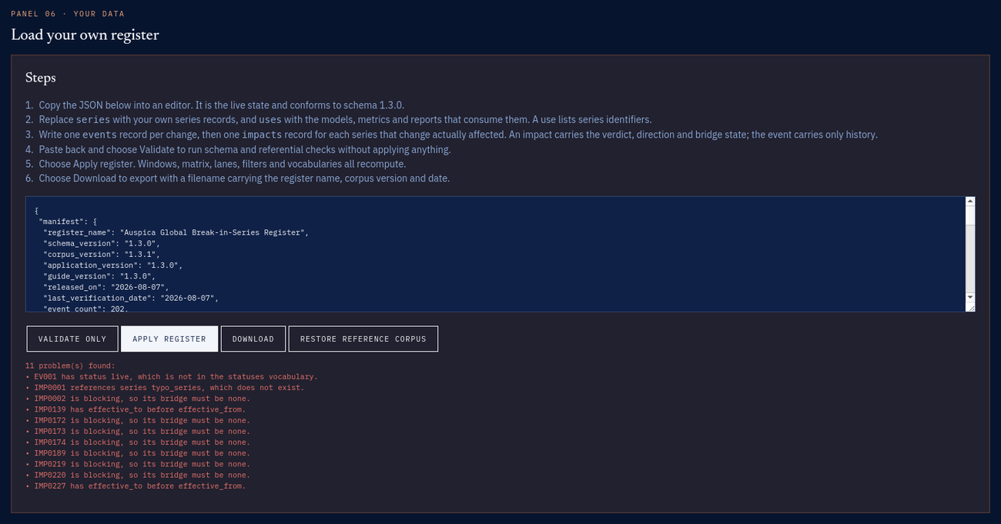
FIGURE 10 Validation output after four faults were introduced deliberately: a status that is not a real status, a reference to a data set that does not exist, and an impact marked unfixable while also claiming to have a fix. Nothing was applied.
IF IT SAYS | IT MEANS
That is not valid JSON | A typing error in the file, usually a stray comma before a closing bracket.
... is not in the vocabulary | You used a word the register does not know. Check the spelling against Panel 05.
... references X, which does not exist | You pointed at a data set or event that is not in the file. Usually a typo in an identifier.
... needs a real date | The date is missing, the wrong shape, or not a real day. Use the first of the month if you only know the month.
... is blocking, so its bridge must be none | You marked something unfixable and also gave it a fix. Decide which is true.
§ 09 · LIMITS

Limits and Honest Use
What the tool will not do for you, and what to expect the first time you point it at your own estate.

What the tool does not do
- It does not find changes. Finding them is human work, or statistical work done elsewhere. This is where you record what you found.
- It does not fix data. It tells you a fix is needed and what kind.
- It does not calculate corrections. Where an overlap period exists, that is ordinary statistical work for whoever owns the data.
- It does not replace a data catalogue. A catalogue says where a number came from; this says whether numbers from that source have meant the same thing over time.

About the loaded examples
- They are real and sourced, but the collection demonstrates the model rather than surveying the world. It leans heavily towards the United States and international standards bodies.
- Absence from it says nothing about whether a series has changed.
- Every entry names the organization that published the change, but source documents are cited rather than linked. Check an entry against its named source before relying on it in an audit or anything published.
- Several changes were phased in over years rather than on one day. The register stores the effective date and describes the phasing in the detail.

One thing worth expecting
When you first run this on your own data, some answers will be shorter than you expect and one or two may return no clean window at all. That is usually correct and usually useful. An empty result is not a failure of the tool. It is the tool telling you that a particular piece of work cannot rest on raw data and must document its adjustments.
APPENDIX A

Glossary
TERM | PLAIN MEANING
Event | Something that changed: a definition, an instrument, a rule, a system.
Impact | What one event did to one particular set of data.
Series | A set of data published or produced over time, for example a national price index.
Use | Something you do with data: a report, a model, a metric, a submission.
Clean window | The stretch of time a use can rely on, calculated from the impacts that touch it.
Raw window | What the originally published data supports if you do nothing.
Adjusted window | What you get after applying the official corrections that exist.
Verdict | How serious an impact is: not comparable, adjustable, or comparable but worth noting.
Bridge | Whether a conversion between old and new exists, and whether it has been applied.
Direction | Which side of the date is spoiled: the past, or everything afterwards.
Declared | The organization responsible announced the change.
Detected | The change is visible in the numbers themselves.
Break in series | The formal name for one of these joins. Statistical agencies have published them for decades.
Corpus | The collection of examples loaded into the tool.
Manifest | The block at the top of the data file recording versions, counts and licence.

About the figures
Every screen in this manual is release 1.3.11 running on the data it ships with, captured at a 1580 pixel window width. Panels were isolated for legibility and nothing was redrawn. The capture tool lacks CSS grid support and reports a zero-width scrolling pane, so for four figures the browser layout was reproduced with floats and the measured pane width was pinned. The figures show what a browser shows.

